Certificate of Analysis

SALSA® MLPA® Probemix P213 HSP mix-2

Catalogue # | P213-025R, P213-050R, P213-100R
Product name | Probemix P213 HSP mix-2
 | B3-0425
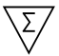 | 25, 50, or 100 reactions.
Shipping conditions | Dry ice or cooling elements.
 | Store upon arrival between -25°C and -15°C.
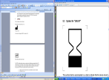 | Expiration date: April 2030, when stored at recommended conditions. This product should not be frozen/thawed more than 25 times.
Purpose | This product has been developed to determine the DNA copy number of the human REEP1 and SPG7 genes, as described in the product description. This probemix is designed for use only in combination with SALSA MLPA reagent kits and Coffalyser.Net analysis software as described in the MLPA General Protocol.
Quality control specifications | - Sufficient distance between peaks, absence of extra or shoulder peaks, and completeness of hybridisation of each individual probe, as tested on Applied Biosystems and Beckman/SCIEX GeXP sequencers.  - Standard deviation of each individual probe ≤0.10, when tested on 23 different DNA samples of healthy individuals, extracted by various methods.  - Each individual probe meets reaction-specific criteria when tested on a single DNA sample under various experimental conditions.  - No-DNA controls result in only five major peaks shorter than 121 nucleotides (nt): four Q-fragments at 64, 70, 76 and 82 nt, and one peak in the range of 0-40 nt corresponding to the unused portion of the fluorescent PCR primer. Non-specific peaks longer than 121 nt AND with a height <25% of the median of the four Q-fragments are not expected to affect MLPA reactions when sufficient (50-250 ng) sample DNA is used. | Test result
Quality control specifications |  | PASS
None of the ingredients are derived from humans, animals, or pathogenic bacteria. Based on the concentrations present, none of the ingredients are hazardous as defined by the Hazard Communication Standard. A Safety Data Sheet (SDS) is not required for these products: none of the preparations contain dangerous substances (as per Regulation (EC) No 1272/2008 [EU-GHS/CLP] and amendments) at concentrations requiring distribution of an SDS (as per Regulation (EC) No 1272/2008 [EU-GHS/CLP] and 1907/2006 [REACH] and amendments). If spills occur, clean with water and follow appropriate site procedures.
More information: www.mrcholland.com; www.mrcholland.eu
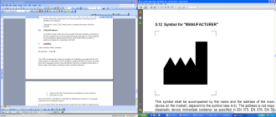 | MRC Holland bv; Willem Schoutenstraat 1  1057 DL, Amsterdam, The Netherlands
E-mail | info@mrcholland.com (information & technical questions)  order@mrcholland.com (orders)
Phone | +31 888 657 200

Certificate of Analysis

SALSA MLPA Probemix P213-B3 HSP mix-2

sample picture

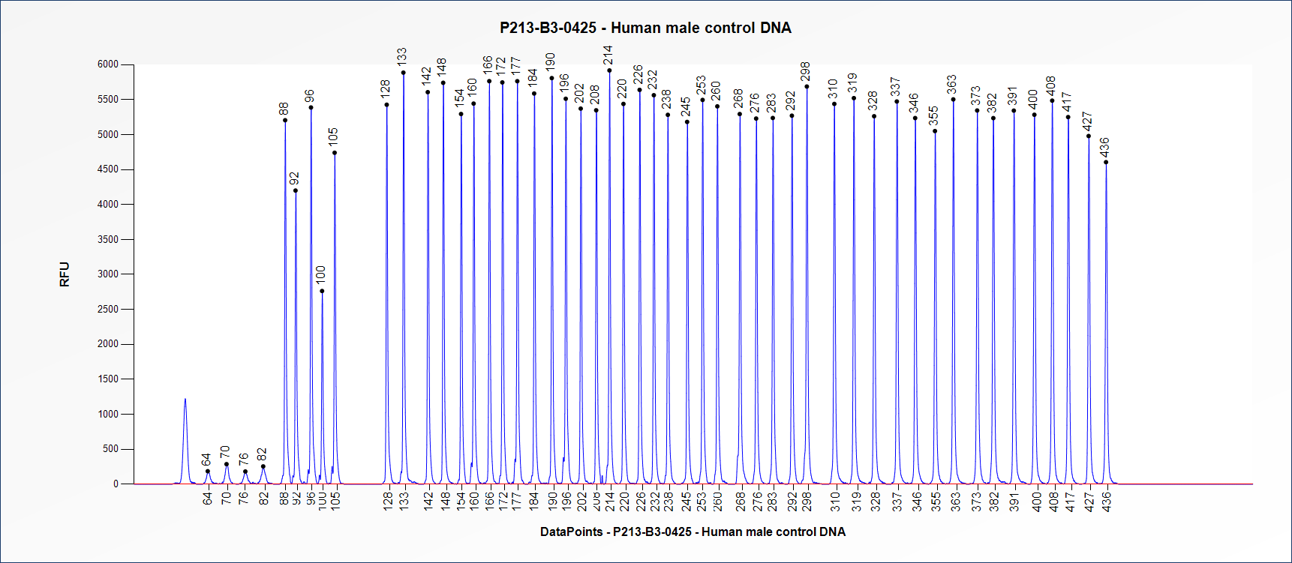Figure 1. Capillary electrophoresis pattern from a sample of approximately 50 ng human male control DNA analysed with SALSA MLPA Probemix P213 HSP mix-2 (B3-0425).

This lot was certified by MRC Holland on 15 July 2025.
This certificate is a declaration of analysis at the time of the manufacturing process. All assays were run in compliance with manufacturer’s instructions for use.
Implemented changes in the COA
Version 01 – 15 July 2025 (6)
- Not applicable, new document.

